
Status L Monthly Reports
Created 1/31/24, updated 2/15/24

Create List Procedure: Status L
- Every month, use the Create Lists functions to find your library’s items that have statuses of $ (lost & paid) and n (billed).
- In Sierra, choose the Create Lists function. Choose an empty Review File with 1,000 or 5,000 records. Click Search Records.
- Change Store Record Type to ITEM-i.
- In Review File Name, give the file a title, such as XX StatusL MMYY where XX is your library’s 2 letter code and MMYY are the month and the last two digits of the year.
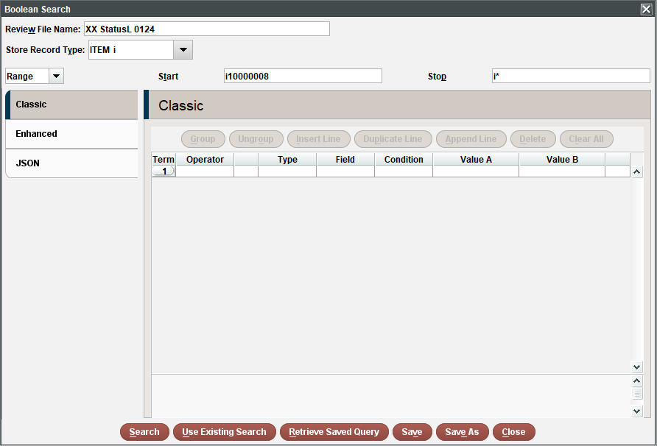
- Click Retrieve Saved Query.
- Click on the query called StatusL, which will find your library’s items in the system that have statuses of $ (lost & paid) and n (billed). Then click Select.
- In the LOCATION search line, change Value A to your library’s 2 letter code.
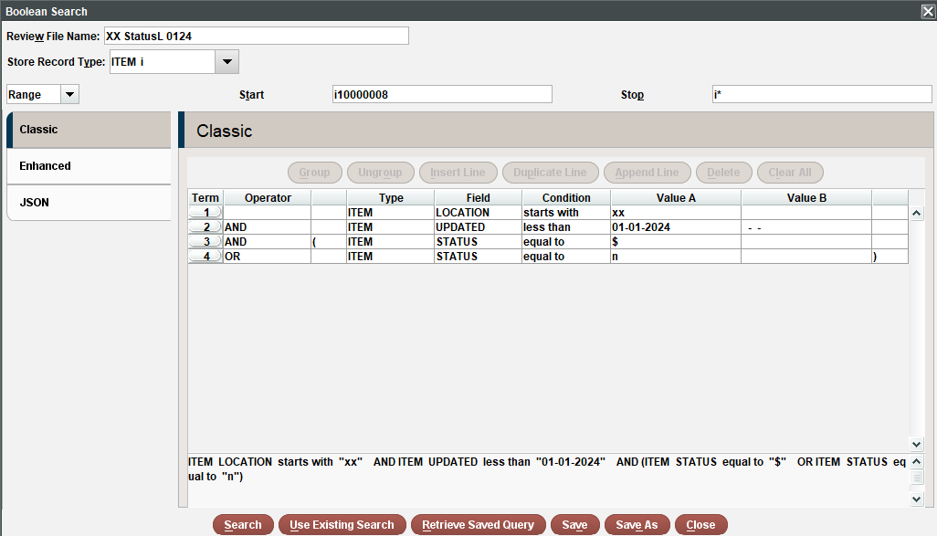
- In the ITEM UPDATED search line, change Value A to the first day of the current month.
- Click Search.
- When the status column for this file says complete, sort the results before exporting. Click on the review file line, then click Sort Records, then click Apply Saved Sort button. Choose LLC Status Reports from the list, then click Select, then click Sort.
- When the review file finishes sorting, export the results by selecting its line, then click the Export Records button. Click Applied Saved Export, then click on LLC StatusL Report, then click Select.
- Click the Browse button next to the File box and choose a location on your computer to save the exported file. Name the file; for example, you could use statusl-mmyy-xx, where mmyy is the month and year, and xx is your library’s 2 letter code. Click Save. Then click OK and the file will begin exporting.
- Open Excel after the file has been exported. Depending on your version of Excel, there may be some variation in the following steps.
- Select the Data tab > From Text/CSV > [Find your saved export file]
- File type is Delimited. Click Next.
- Select what you used as the delimiter, usually either tab (|) or a comma (,).
- Older versions of Excel: the text qualifier must be set to double quotation mark. Click Next. Leave data format as General. Click Finish. Click OK if you are okay with it loading in the current worksheet. Newer versions of Excel: if the above options aren’t given, click on Load.
- If the barcode or other numerical columns shows formulas instead of numbers, right click on the entire column, select Format Cells > Number > Decimal places: 0.
- Save your Excel file locally and take action on the items listed.
- In Sierra, empty your Review File. Click on its line then click the Empty button.

